MULTI-LINE INSURANCE POLICY AND CLAIMS MANAGEMENT SYSTEM
COLLEGE NAME:
UNIVERSITY COLLEGE OF ENGINEERING THIRUKKUVALAI
COLLEGE CODE:
8222
TEAM MEMBERS & REGISTER NO:
SUJITHA S (TEAM LEAD) -822223104047
BRUNDHA C -822223104013
LAVANYA R -822223104051
SHERLINE A -822223104012
EMAIL ID:
SUJITHA S -swethasuresh135@gmail.com
BRUNDHA -brundhachandran2006@gmail.com
LAVANYA -rengappanm7@gmail.com
SHERLINE -sherlineanand09@gmail.com
NM ID:
SUJITHA - 635EA61E9AC61F28B96464EA7AE94979
BRUNDHA- 61256CB7BEBD7D89FAE4DAA8822D17DD
LAVANYA- 30С2B65EFDDEA08A18B4A89FF2BACA63
SHERLINE- D1EFEE8668DAC58929743E48C1FBAFBD
TEAM LEAD PROFILE LINK: https://www.salesforce.com/trailblazer/n1wdpejyytmf2wh61w

1. PROBLEM STATEMENT
The insurance company manages Vehicle, Property and Life insurance through processes that can become slow and difficult to control when policy information, quotations and claims are handled separately. The proposed Salesforce solution brings these activities into one platform so policy and claim information can be maintained together.
- Standardize policy quoting and issuance.
- Capture product-specific information in a common data model.
- Automate claim creation, routing and approval.
- Provide role-based access to agents, adjusters and managers.

2. OBJECTIVES
- Create a flexible Policy and Claim data model for Vehicle, Property and Life insurance.
- Use Record Types and Field Sets for product-specific information.
- Build a guided Auto Quoting Screen Flow.
- Calculate premiums through Apex.
- Route claims according to policy type.
- Provide an LWC Claims Dashboard.
- Implement approval processing for high-value claims.
- Apply Sharing Rules and Permission Sets.
- Test automation and Apex before completion.

3. CHALLENGES
- Managing different fields for three insurance products.
- Routing claims according to the related policy type.
- Connecting Salesforce Flows with Apex logic.
- Building a useful adjuster dashboard.
- Maintaining security while supporting daily work.

4. SOLUTION APPROACH
The project uses Salesforce as a centralized platform. Policy and Claim are custom objects, Record Types separate insurance products, Screen Flow supports guided quotation, Apex handles premium calculation and claim retrieval, and Record-Triggered Flows automate routing and updates. LWC provides the adjuster dashboard, while Approval Processes, Sharing Rules and Permission Sets support processing and security.

5. MILESTONES

Milestone 1: Core Data Model & Policy Configuration

User Story 1: Creation of Custom Objects
Create the Policy custom object with Policy Number as an Auto Number record name, format P-{0000}, starting number 1. Enable reports, activities and field history, deploy the object and allow search.
Create the Claim custom object with Claim Number as an Auto Number record name, format C-{0000}, starting number 1. Enable reports, activities and field history, deploy the object and allow search.
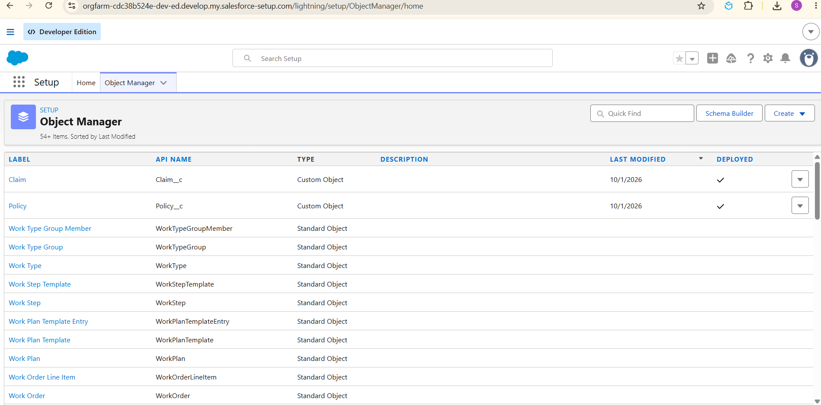

1. Define Record Types on Policy Object
Create Auto, Property and Life Record Types on Policy. Keep them active and available to the required profiles.
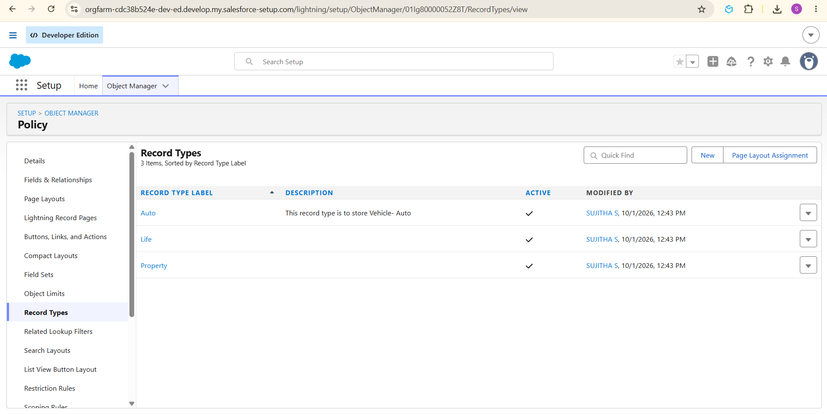

2. Create Field Sets for Policy-Specific Data
Policy Type | Field Set | Fields
Vehicle | Vehicle | VIN, Model Year
Property | Property | Square Footage, Year Built
Life | Life | Beneficiary Name, Policy Term Months

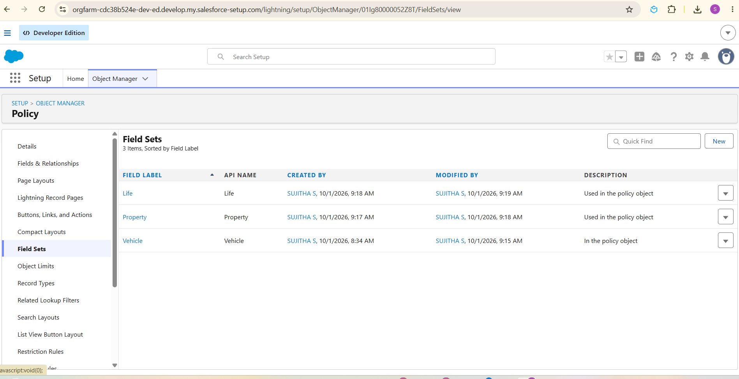

3. Create Fields in the Policy Object
S.No | Field | Data Type
1 | Beneficiary Name | Text(50)
2 | Customer | Lookup(Contact)
3 | Model Year | Text(5)
4 | Policy Start Date | Date
5 | Policy Term Months | Number(18,0)
6 | Premium | Currency(16,2)
7 | Square Footage | Number(18,0)
8 | VIN | Text(20)
9 | Year Built | Text(5)

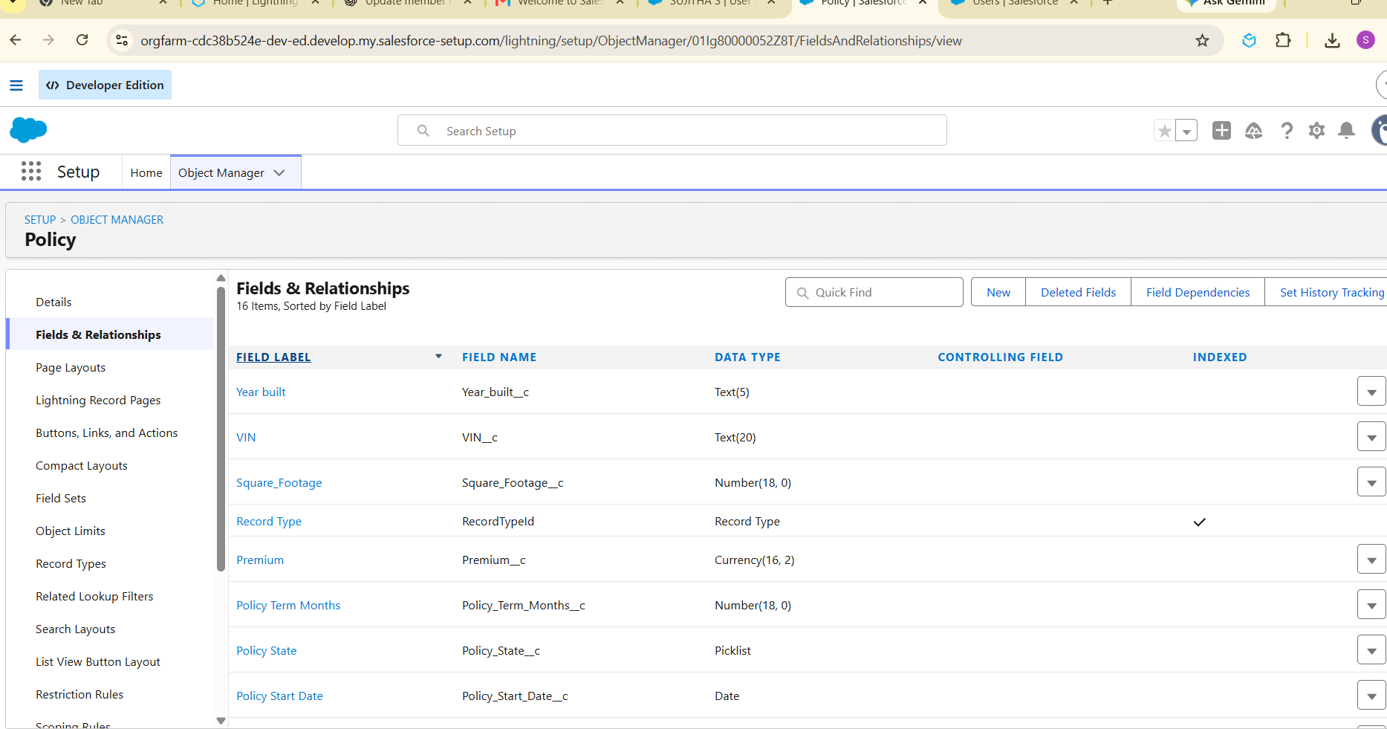

4. Define Record Types on Claim Object
Create Accident, Property and Life Claim Record Types.
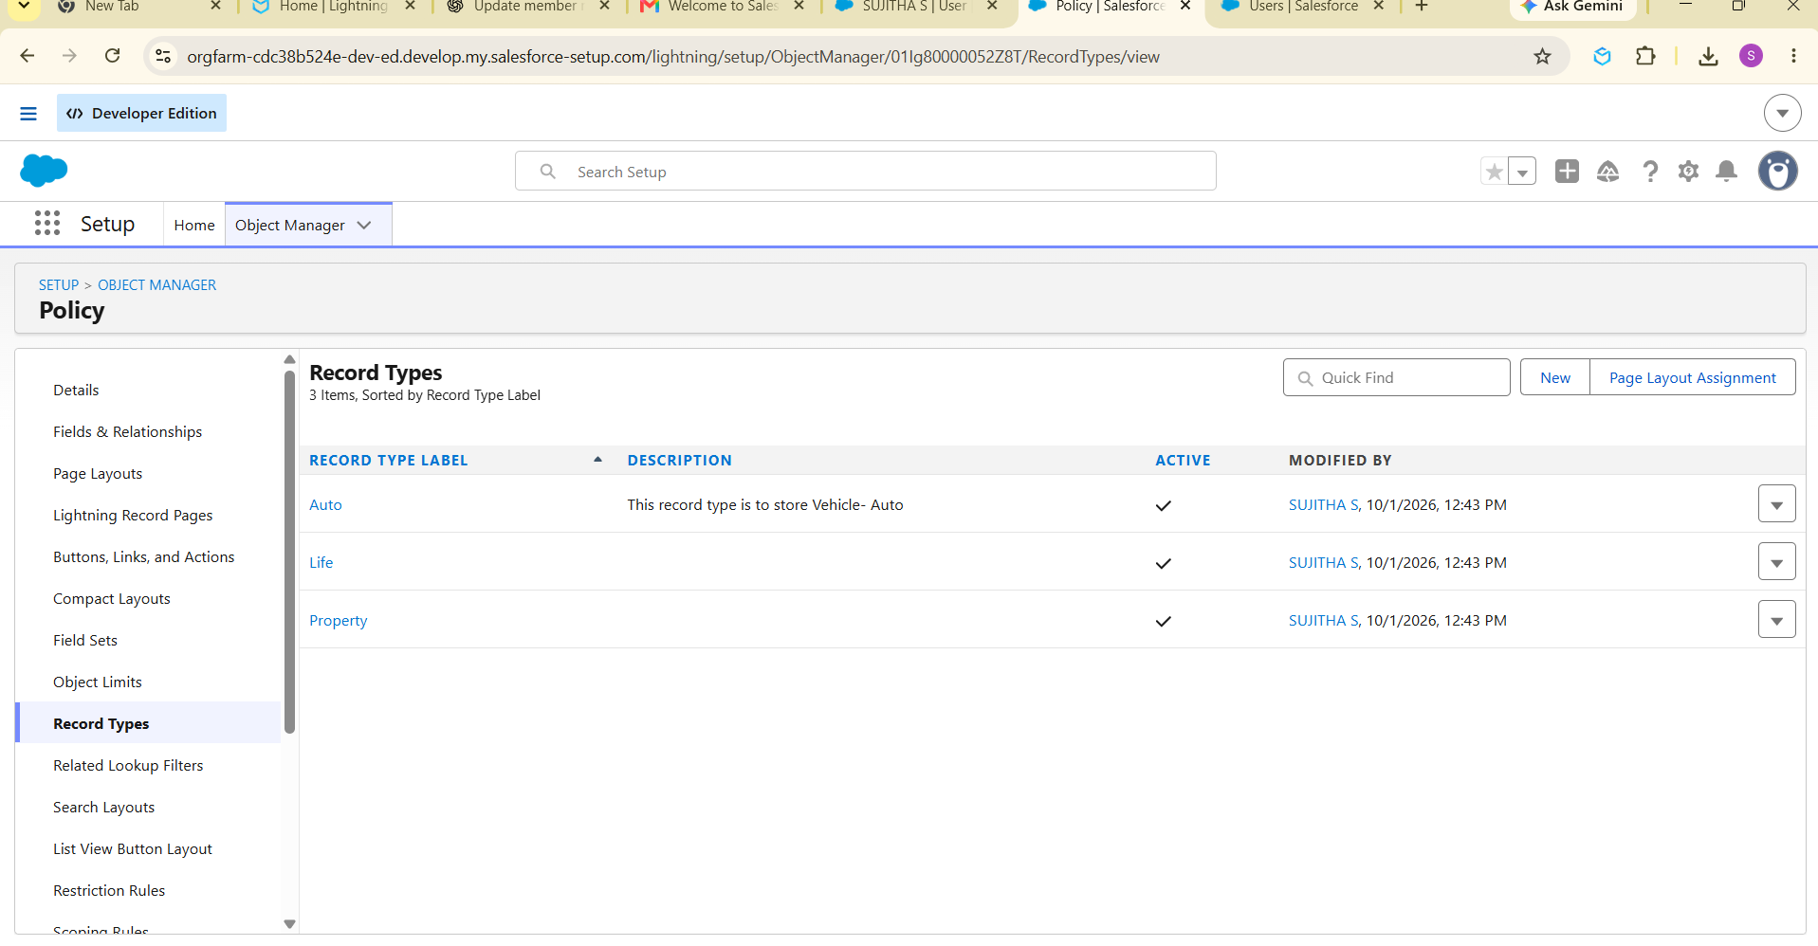

5. Create Fields in the Claim Object
S.No | Field | Data Type
1 | Adjuster | Lookup(User)
2 | Approval Status | Picklist: New, Submitted for Approval, Approved, Rejected
3 | Claim Amount | Currency(16,2)
4 | Date of Loss | Date/Time
5 | Description | Long Text Area
6 | Policy | Lookup(Policy)

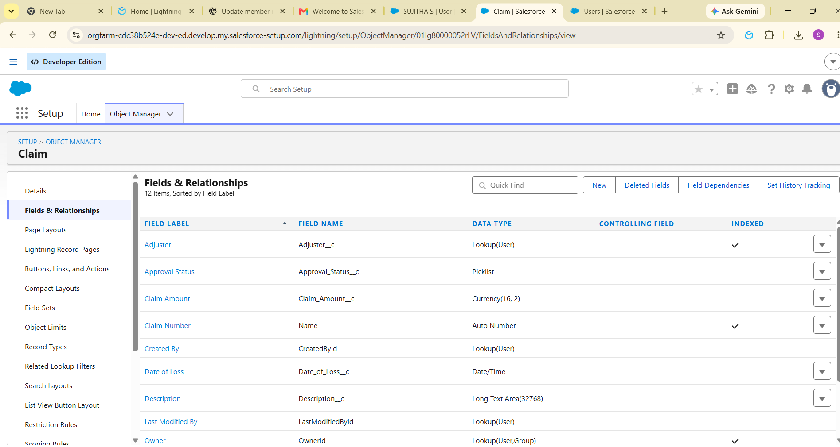

6. Create an AutoQuoting Screen Flow
- Create AutoQuotingFlow as a Screen Flow.
- Retrieve the Auto Policy Record Type.
- Create a basic information screen for customer, policy start date and state.
- Create a vehicle-specific screen for VIN and Model Year.
- Create a draft Policy record.
- Store the created Policy Id in a variable.
- Save and activate the flow.
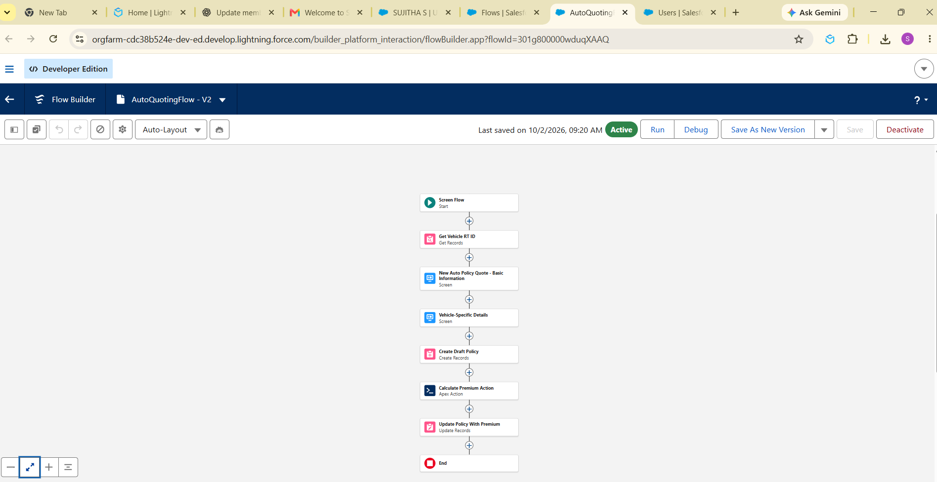

7. Create Validation Rule on Policy Object
Create VIN_Must_Be_17_Characters for Auto policies. The rule checks that VIN contains exactly 17 characters and displays an error on the VIN field.
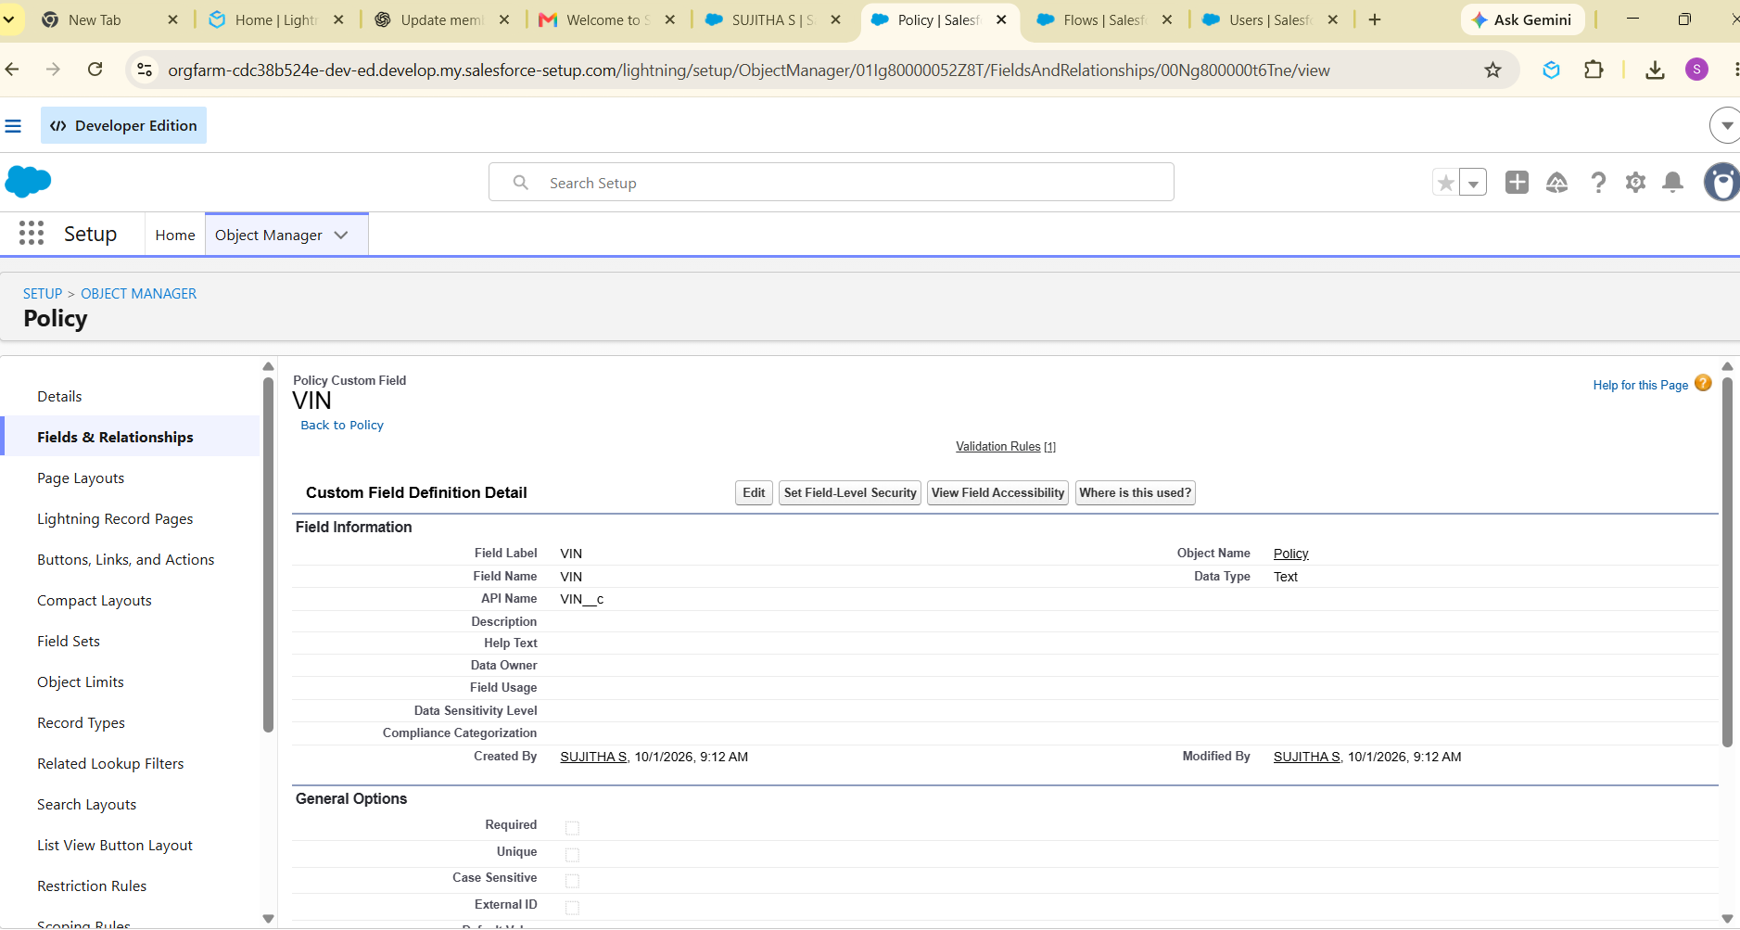

Milestone 2: Complex Policy Issuance & Claim Routing Automation

1. Create an Apex Class (PremiumCalculator)
Create PremiumCalculator with an invocable method that receives a Policy Id, reads policy information and returns a calculated premium using the configured rating logic.
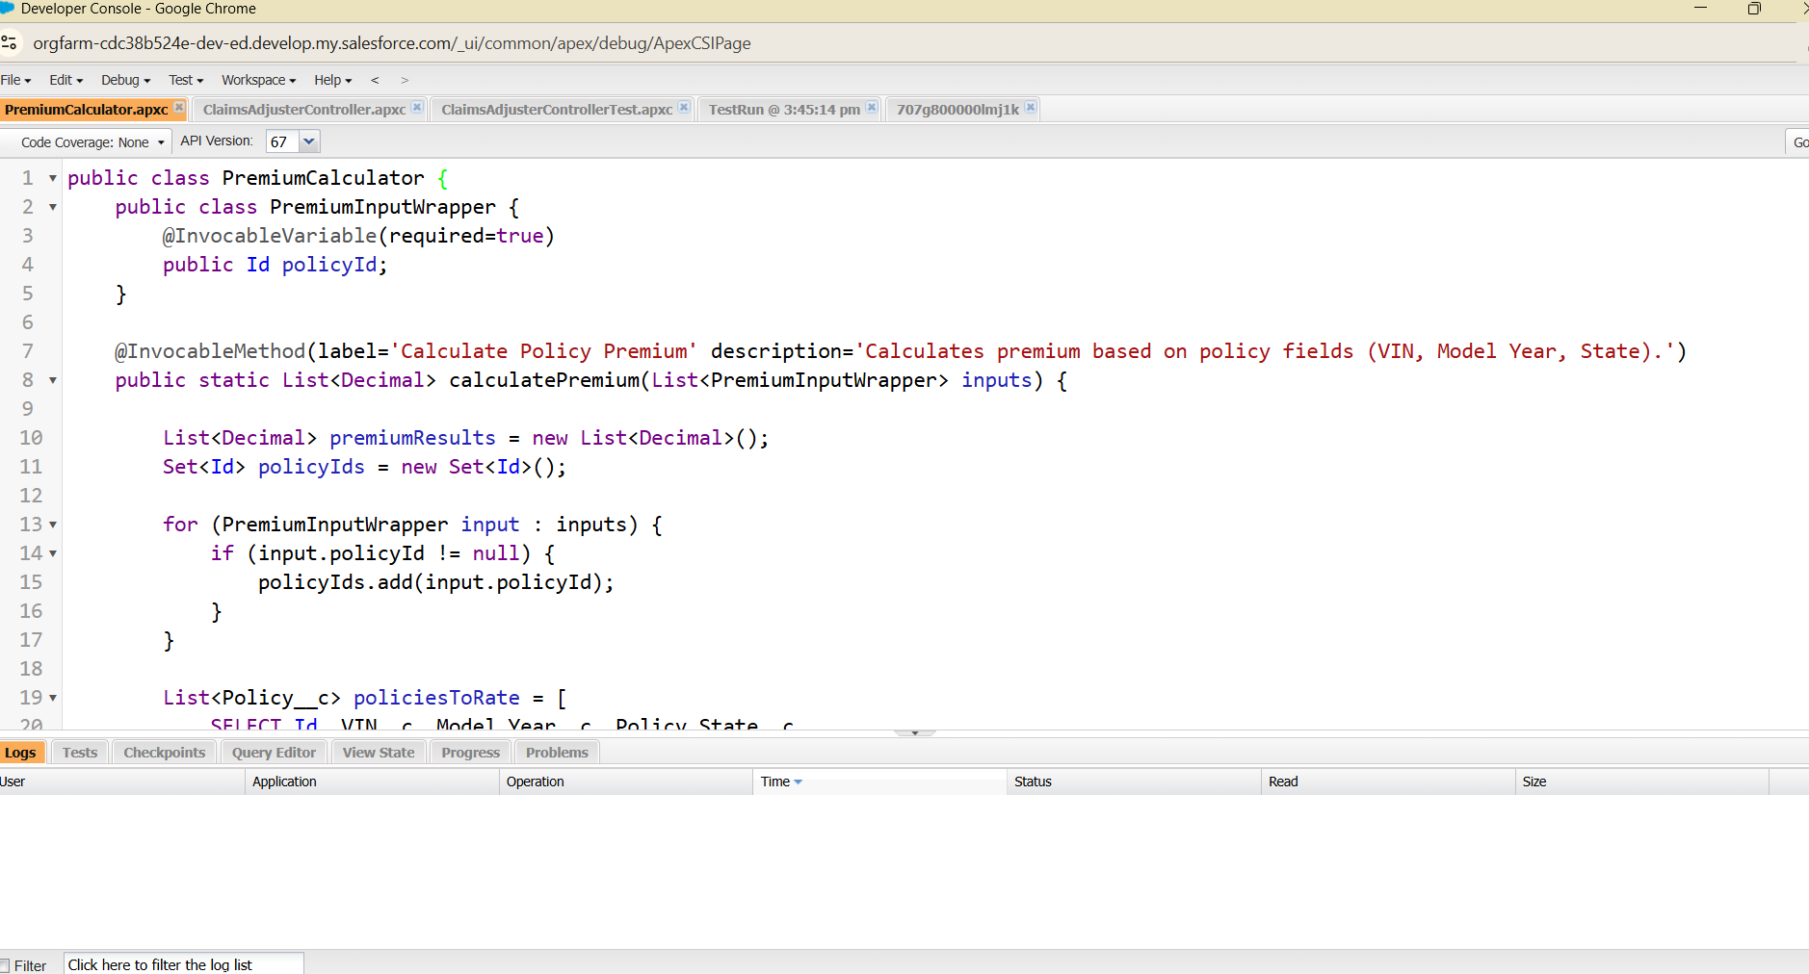

2. Integrate this Apex action into AutoQuotingFlow
- Add Calculate Premium Action after draft Policy creation.
- Pass the Policy Id variable.
- Store the returned premium in a currency variable.
- Update the draft Policy Premium field.
- Save a new version and activate.
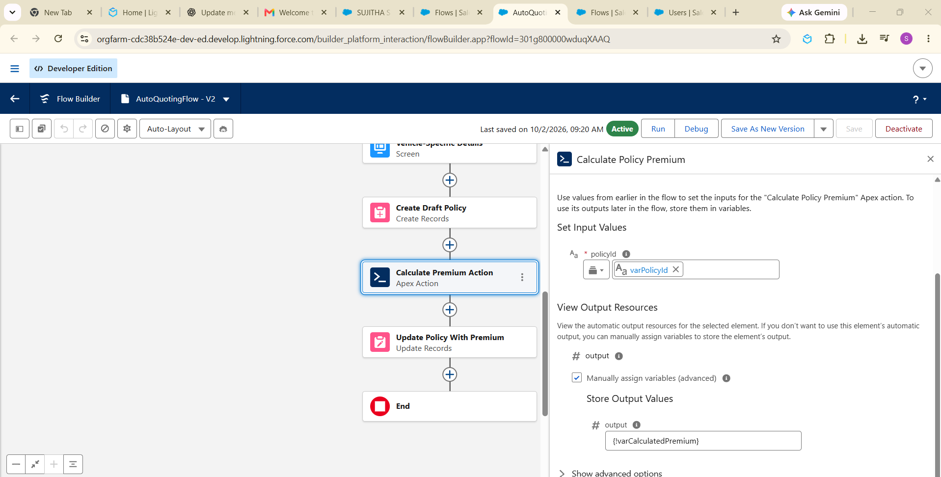

3. Create a Record-Triggered Flow (After Save) on Claim
- Create the flow on Claim.
- Retrieve the related Policy.
- Identify the Policy Record Type.
- Use a Decision element for Auto, Property and Life.
- Assign Auto claims to Auto queue.
- Assign Property claims to Property queue.
- Assign Life claims to Life queue.
- Save and activate.
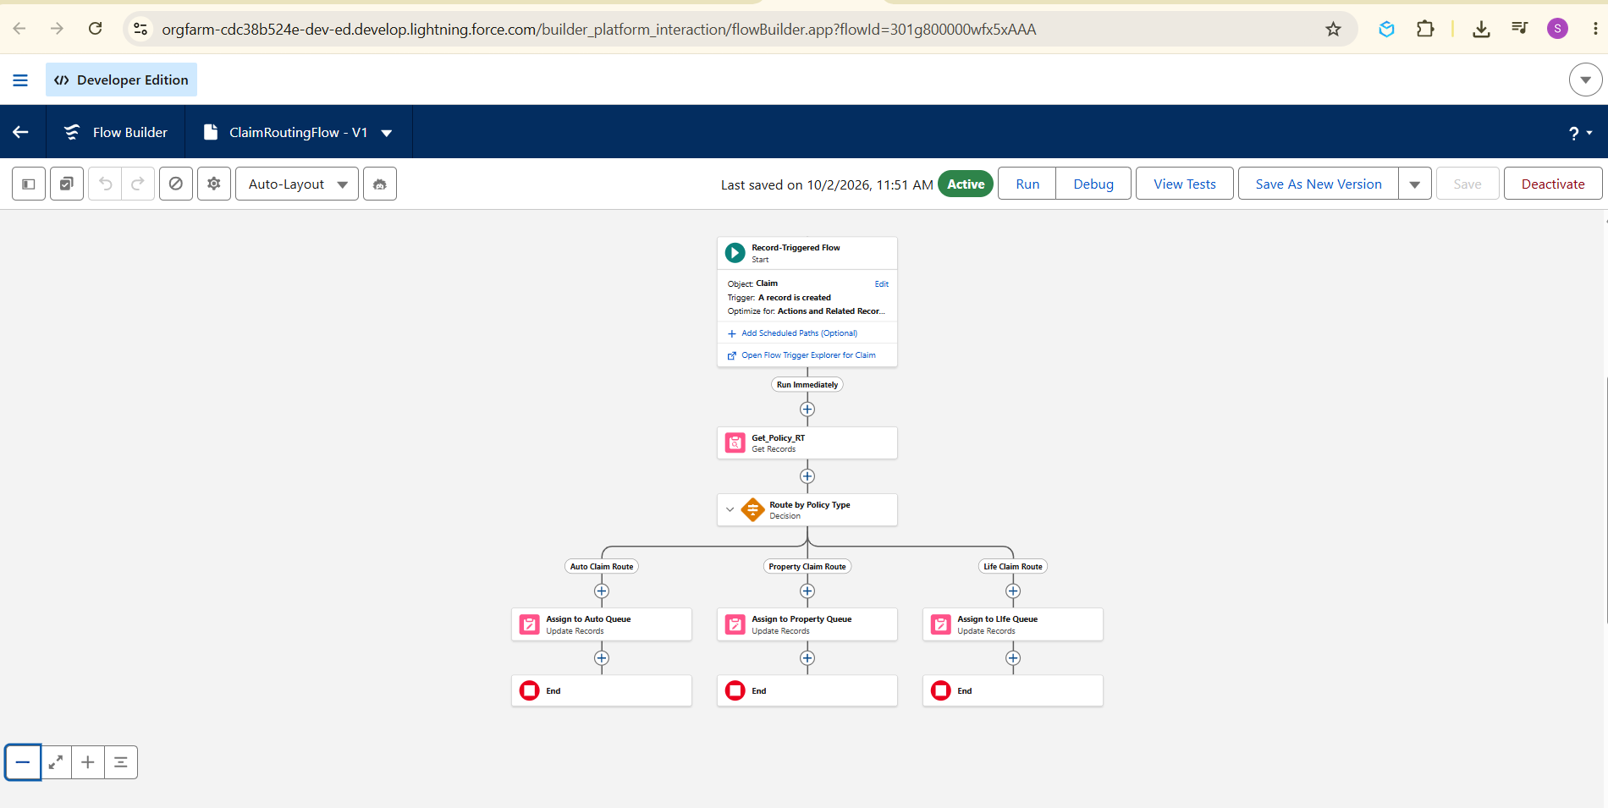

Milestone 3: Claims Adjuster LWC Dashboard Development

1. Create a robust Apex class (ClaimsAdjusterController)
Create ClaimsAdjusterController to query claims owned by the logged-in user and return claim number, amount, status, policy type, policy holder and days open through a wrapper class.
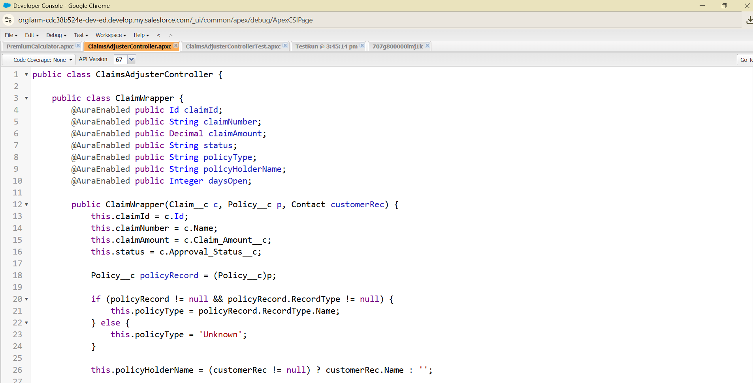

2. Create claimsDashboardLwc
- Create and expose the LWC.
- Call the Apex method using @wire.
- Display assigned claims.
- Provide All, Auto, Property and Life filtering.
- Show the number of visible assigned claims.
- 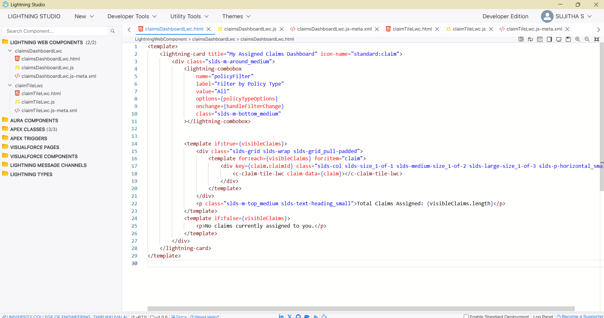
- 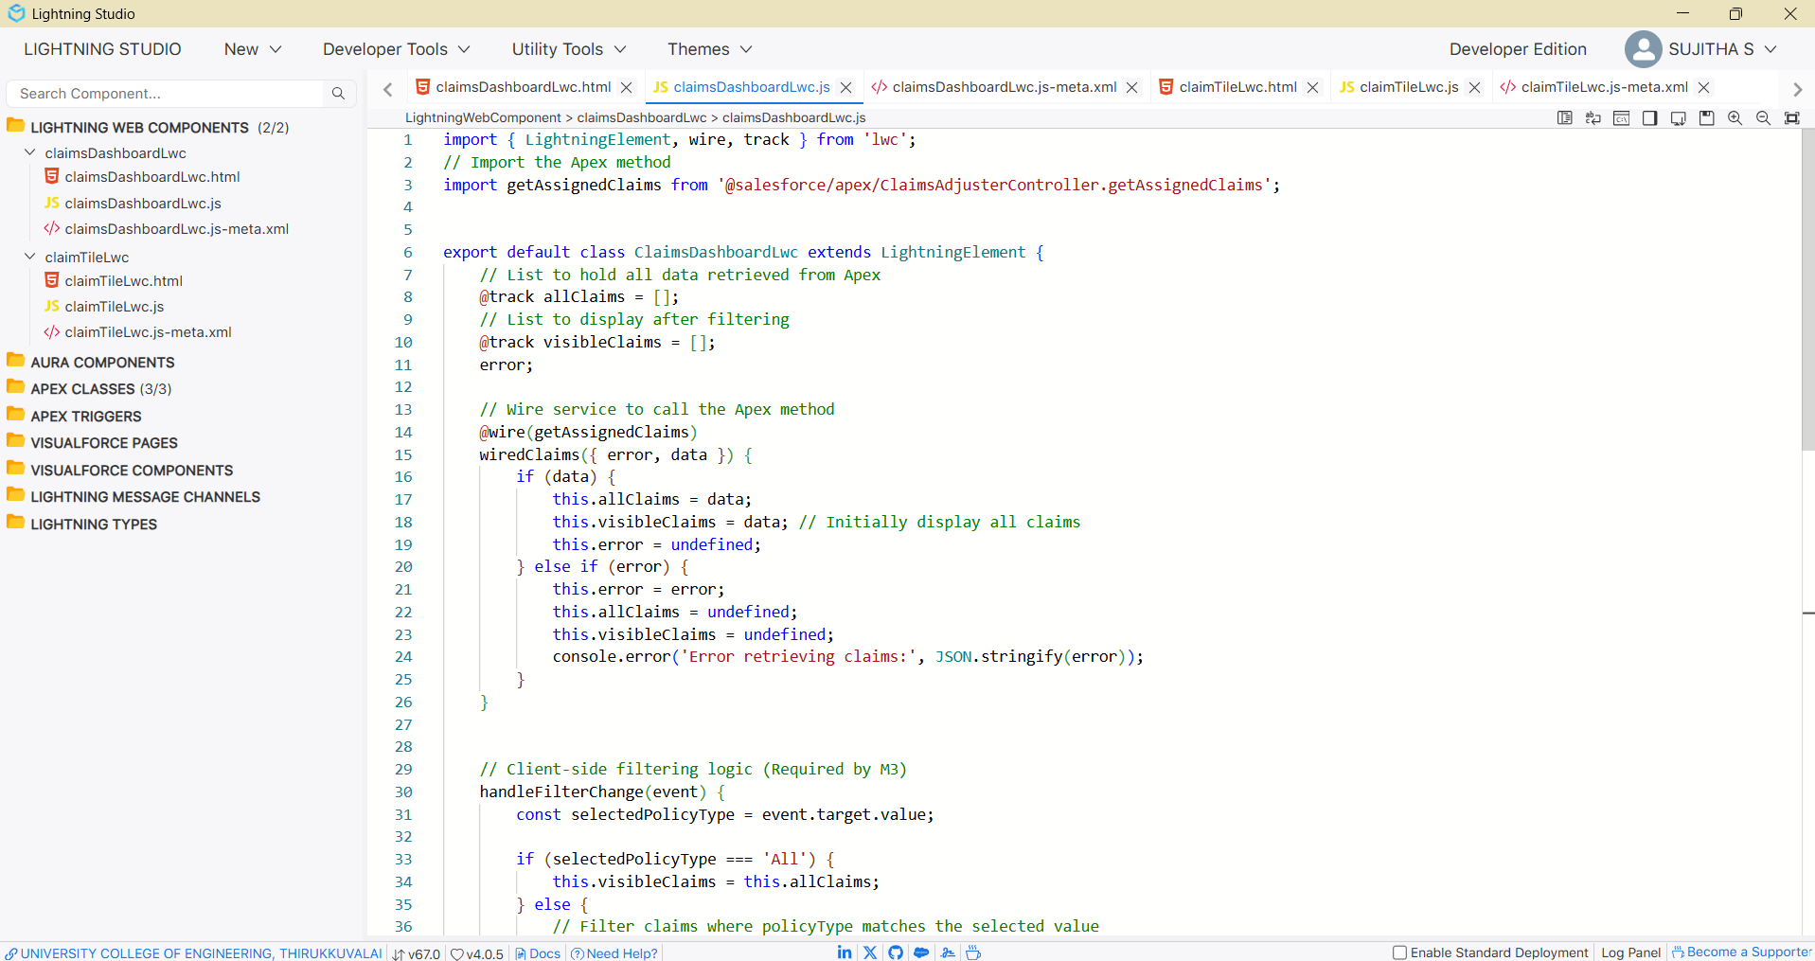
- 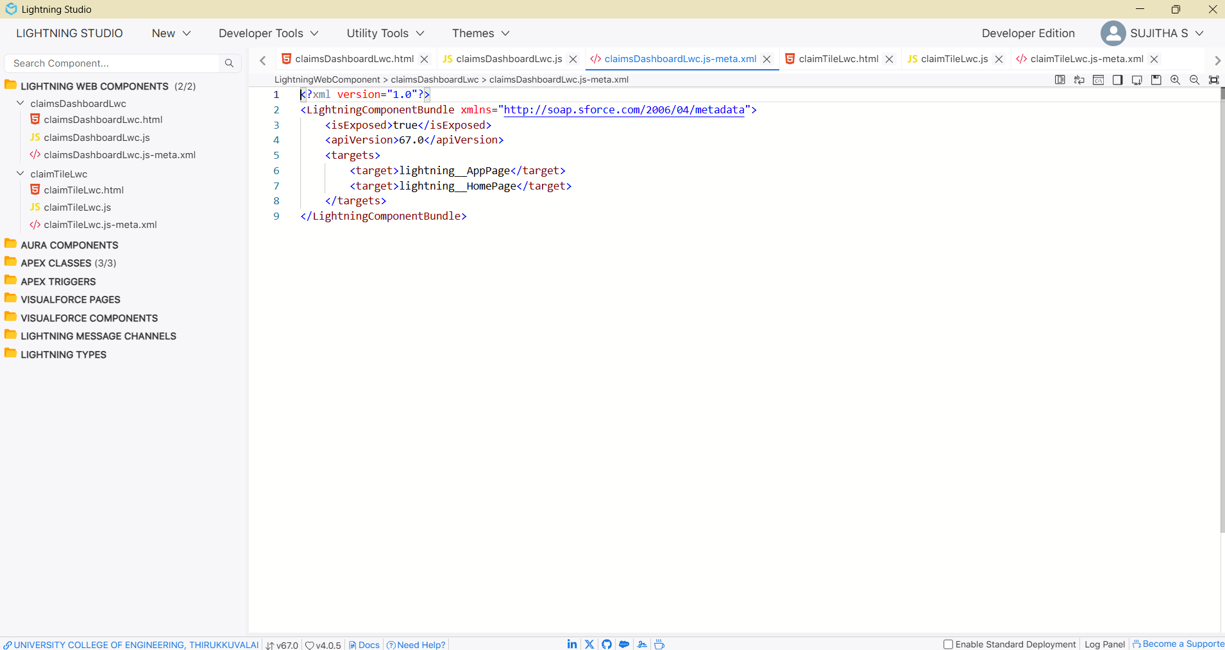

3. Create a reusable component (claimTileLwc)
Create a child component to display each claim's number, policy type, policy holder, amount, status and days open. The component can show a suitable icon based on policy type.
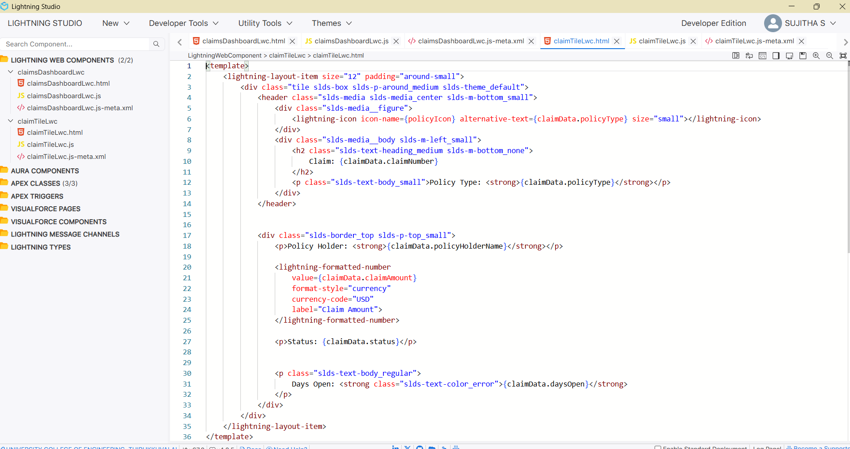
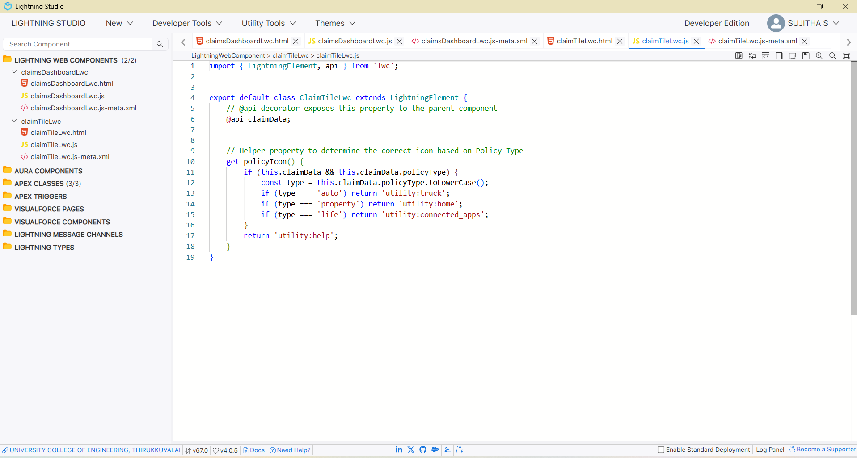
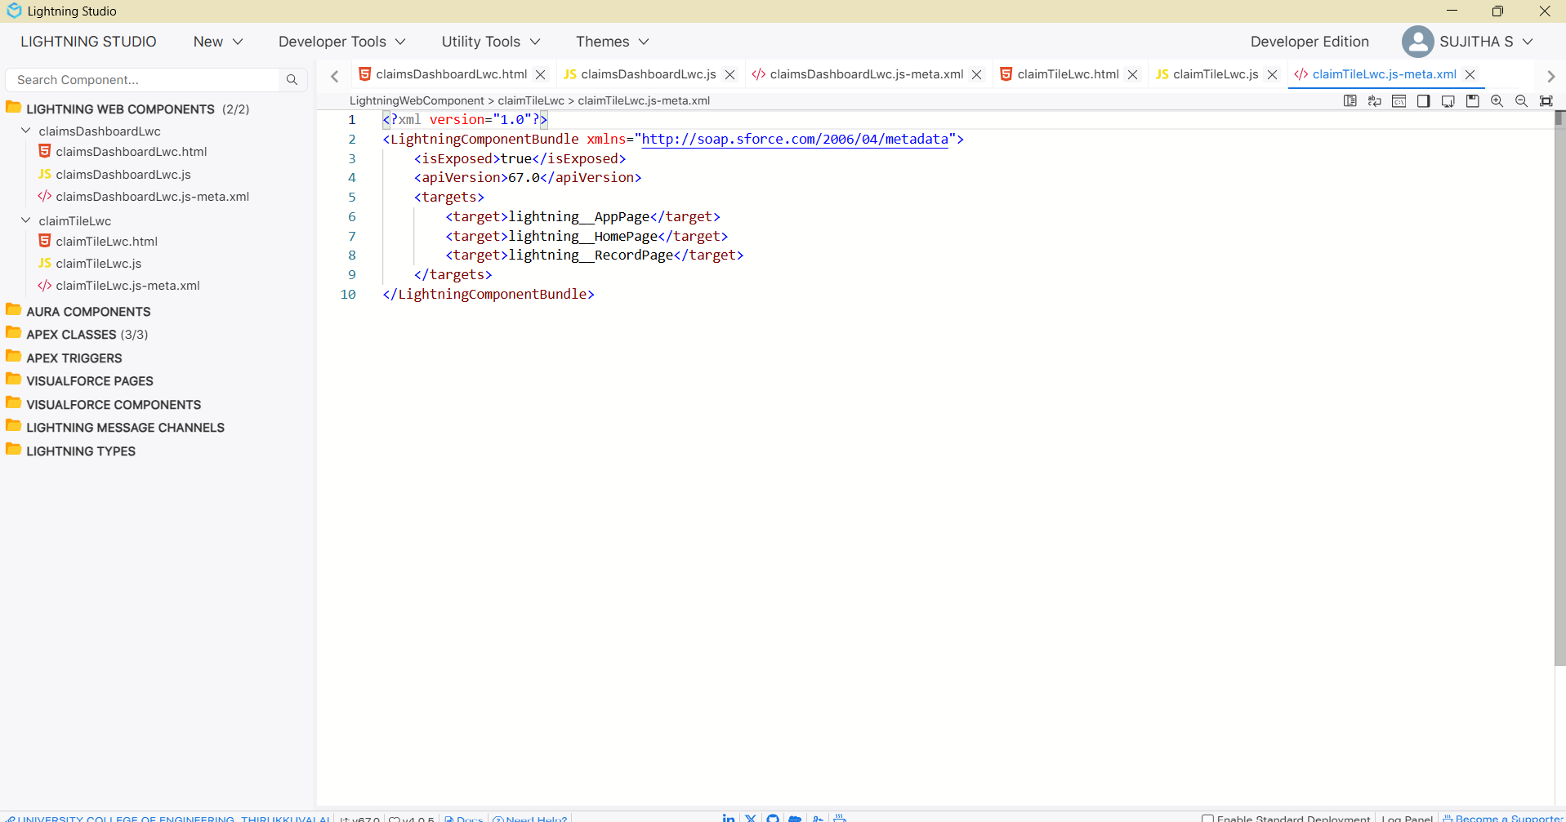

Milestone 4: Advanced Claim Processing, Security & Code Setup

1. Modify the Claim object to include an Approval Status field
Create a picklist with New, Submitted for Approval, Approved and Rejected
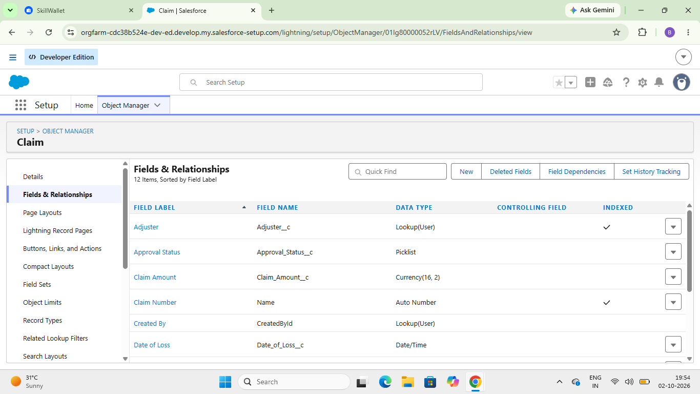.

2. Configure the Approval Process
- Create High Value Claim Approval.
- Set entry criteria to Claim Amount greater than 50,000.
- Allow the Claim owner to submit.
- Step 1: Senior Adjuster.
- Step 2: Department Manager.
- Set status to Submitted for Approval on submission.
- Set status to Approved after approval.
- Set status to Rejected after rejection.
- Activate the process.
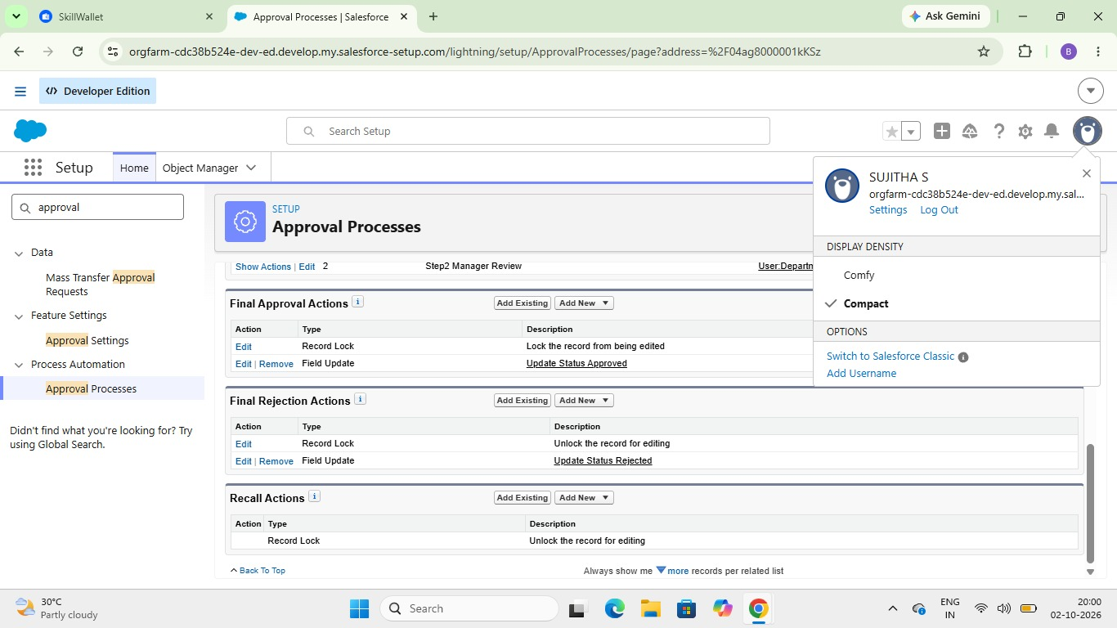l

3. Create a Record-Triggered Flow for high-value claims
Create an After-Save Claim flow that checks Claim Amount > 50,000 and Approval Status = New, then submits the record to High Value Claim Approval.
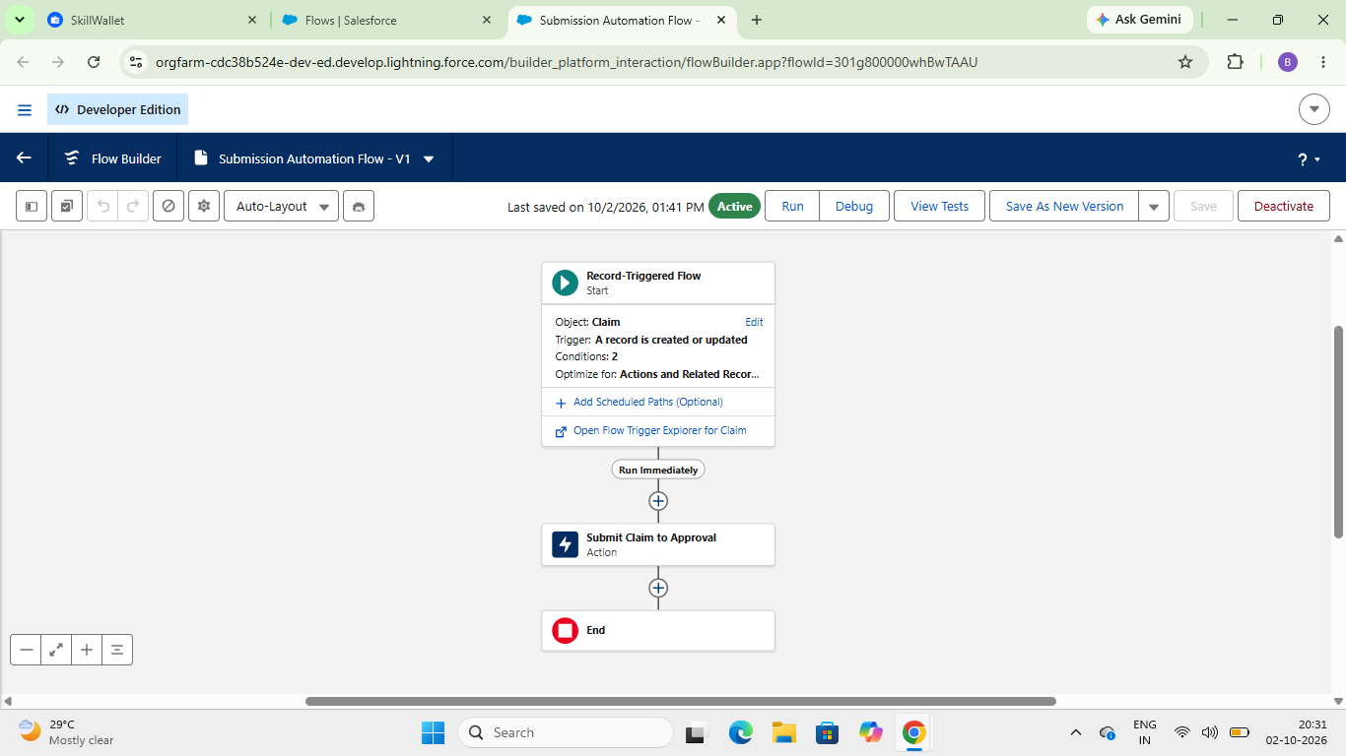

4. Implement a Screen Flow for approvers
- Create an input variable named recordId.
- Get Claim Details.
- Display Claim ID, Amount and Policy Type.
- Add Approve and Reject choices.
- Capture approver comments.
- Use a Decision element.
- Submit the selected approval action.
- Create Approve/Reject Claim Quick Action.
- Add it to the Claim page layout.
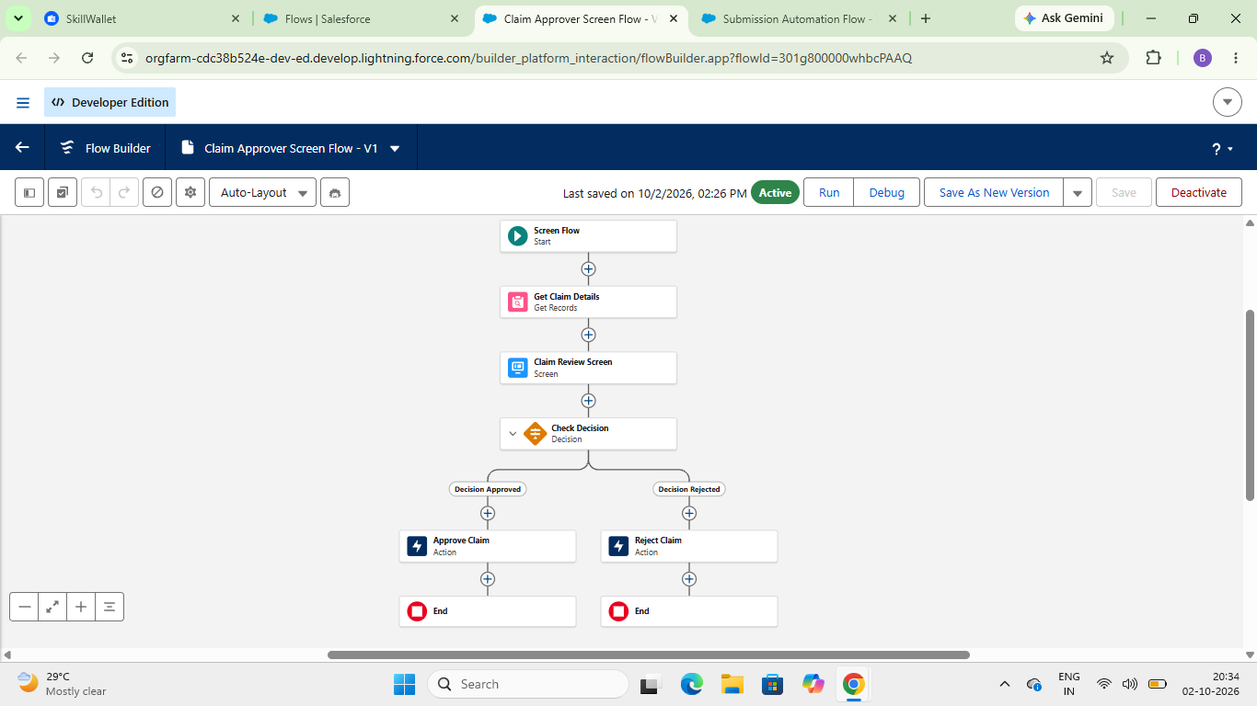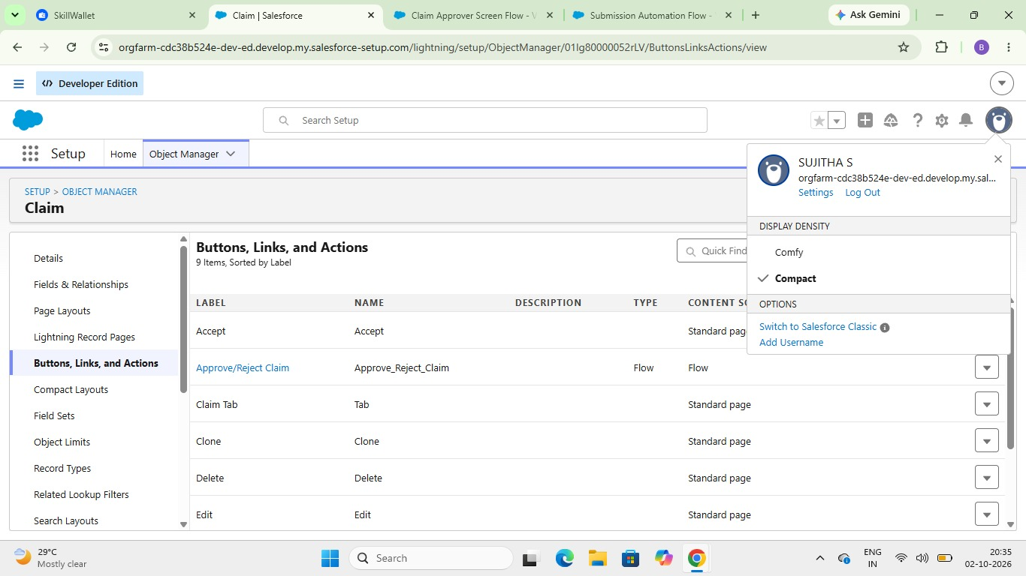
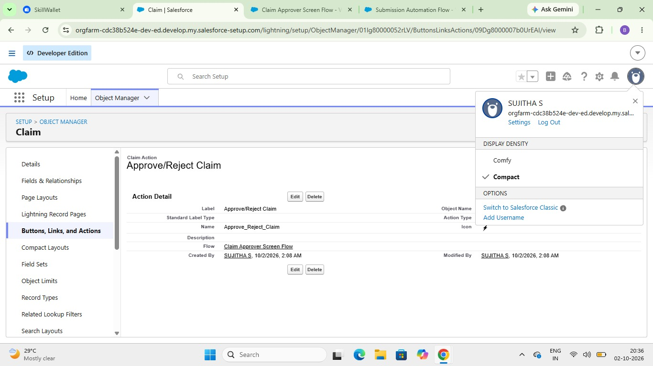

5. Write an Apex Test Class
Create ClaimsAdjusterControllerTest with test data for User, Contact, Policy and Claim. Run the controller method and verify returned values. The project target is 95% or higher coverage. 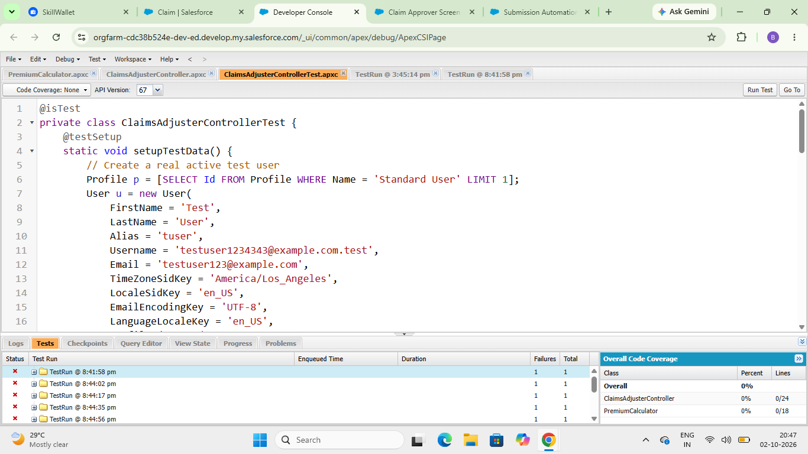
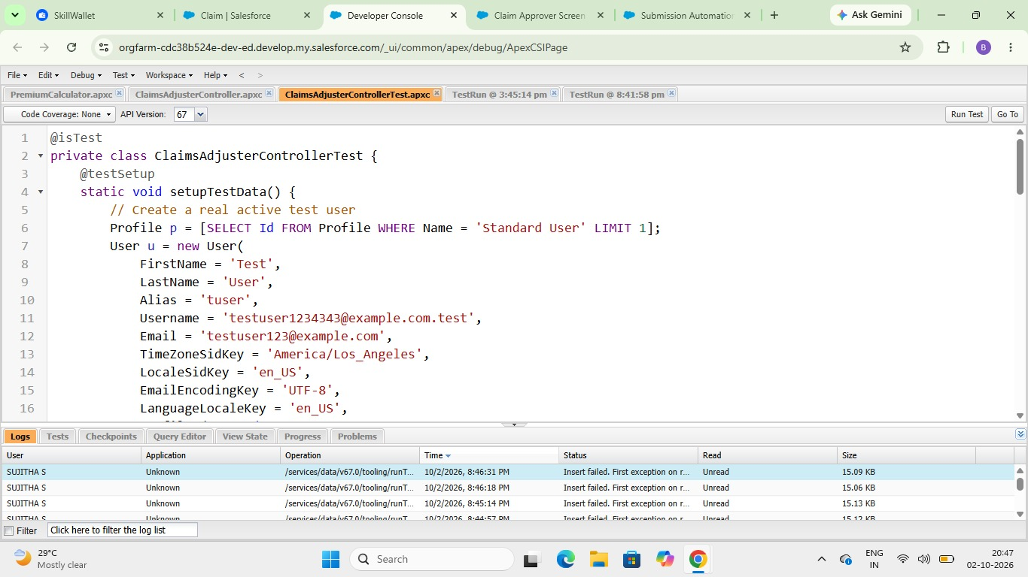

6. Refine the Sharing Rules
Maintain policy-holder state information on Claim and configure Claim Sharing Rules based on applicable state. The implementation includes CA and TX criteria with Read/Write access
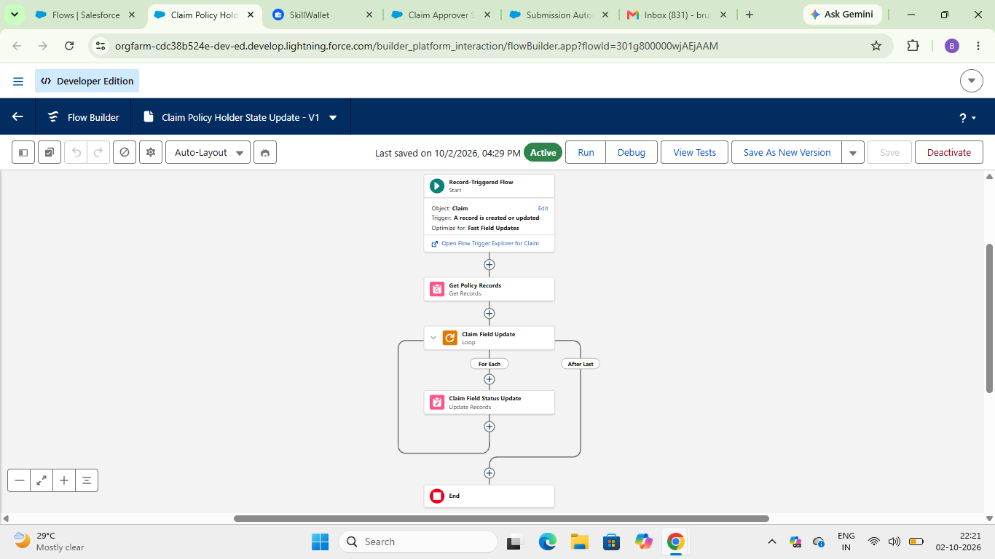
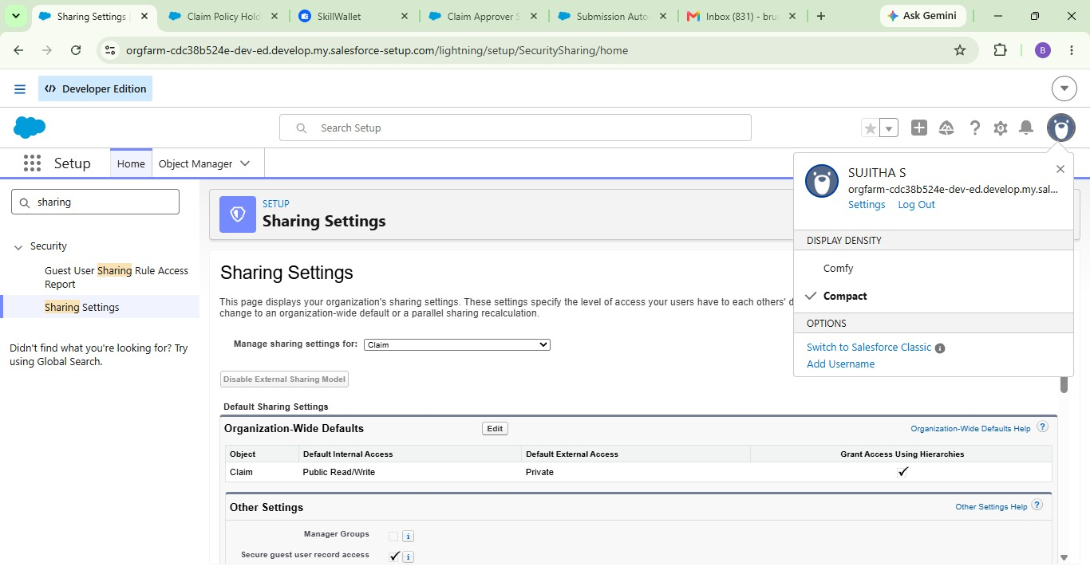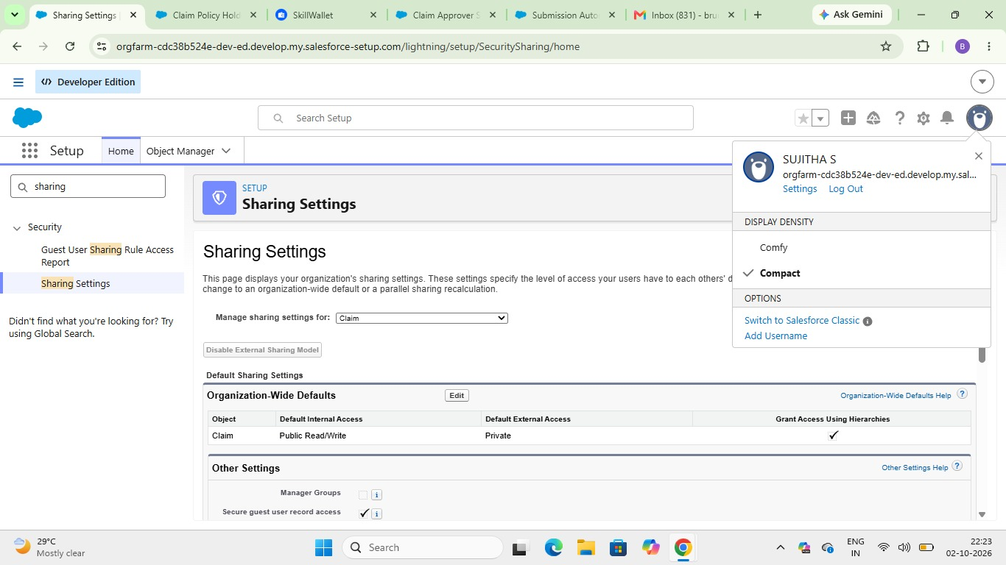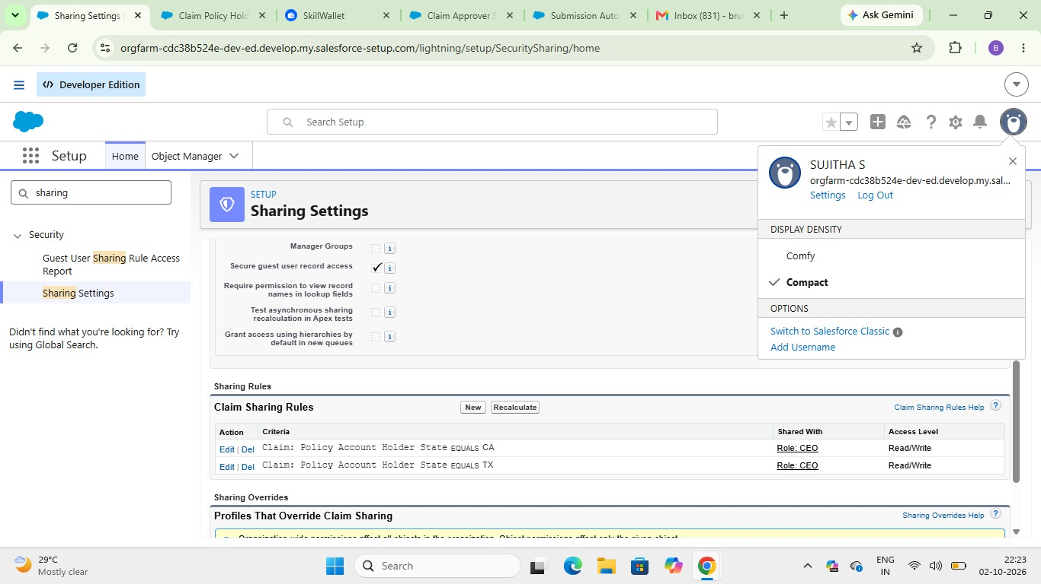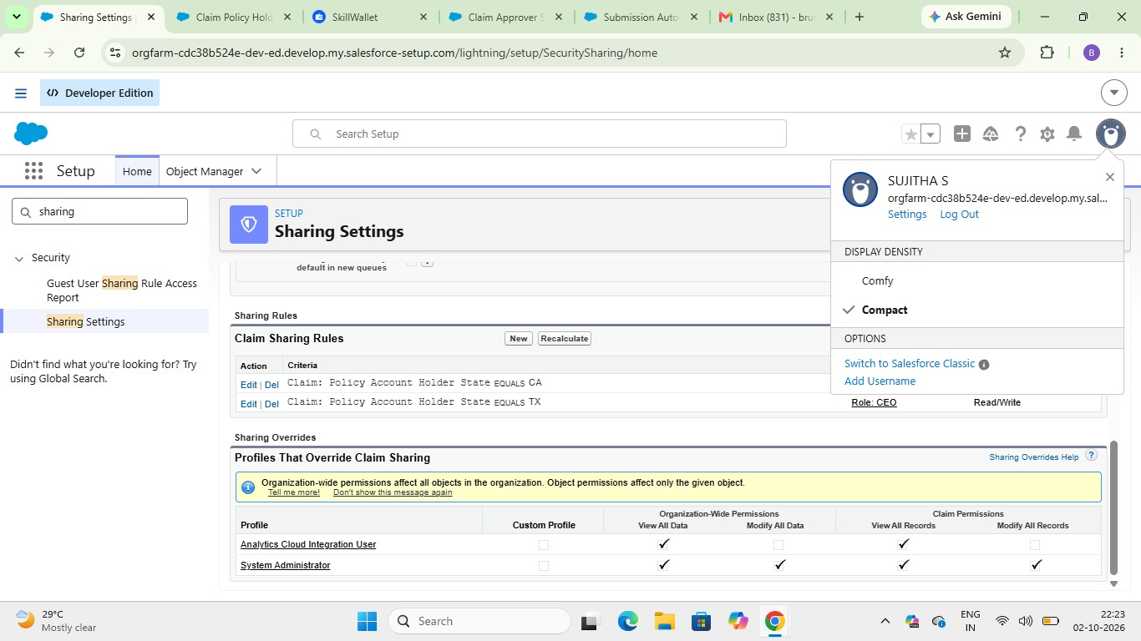.

7. Finalize all Permission Sets
Role | Policy | Contact | Claim | Additional Access
Insurance Agent | Create, Read | Read, Edit | Read | Flow User; PremiumCalculator
Claims Manager | Read | Read, Edit | Read, Edit, Delete | Run Reports; Manage Approvals
Claims Adjuster | Read | — | Read, Edit | ClaimsAdjusterController

7.1 Create Claims Manager Access Permission Set
Provide the Claims Manager with reporting, approval and claim-management permiss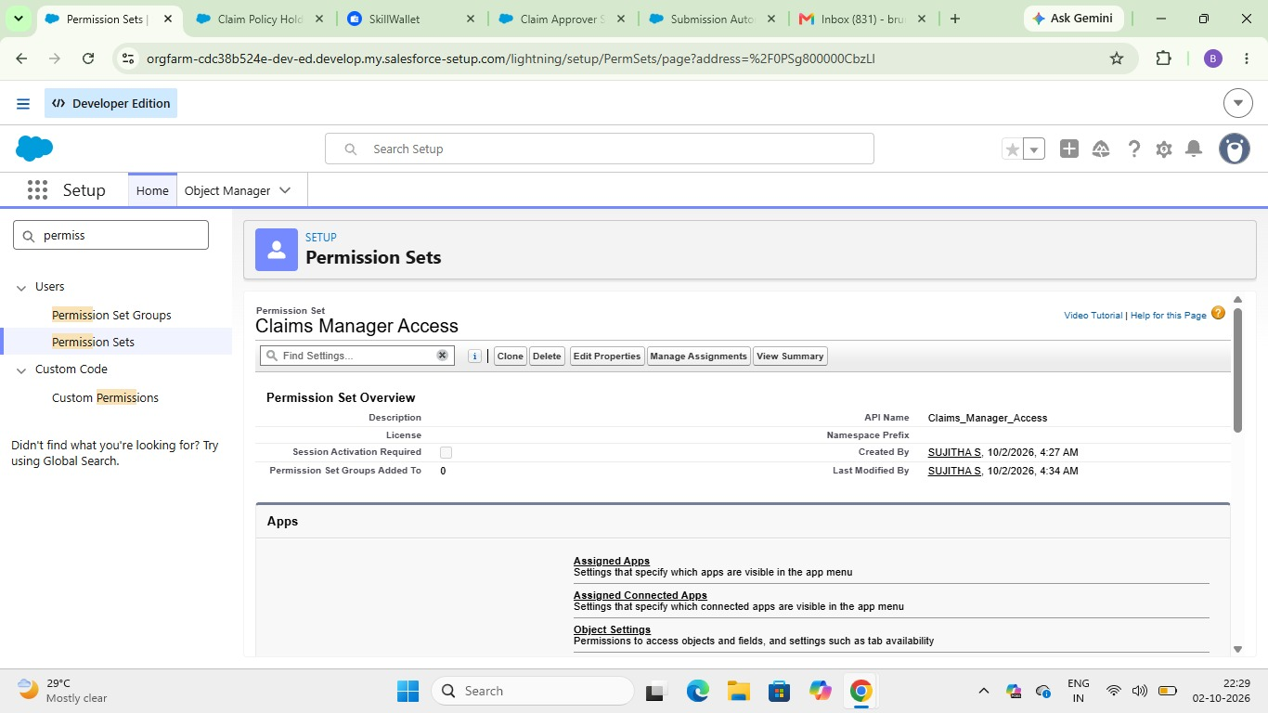.

7.2 Create Claims Adjuster Access Permission Set
Provide Policy read access, Claim read/edit access and ClaimsAdjusterController Apex access.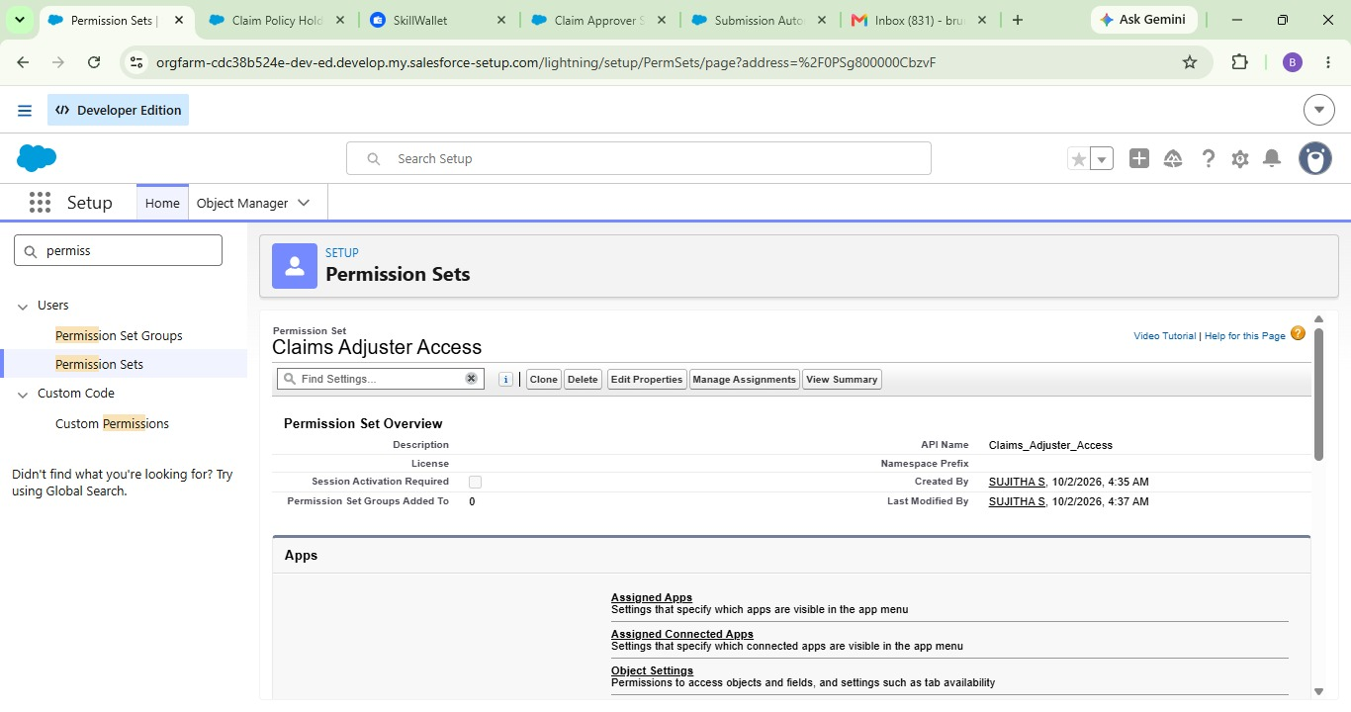

6. FUNCTIONAL & PERFORMANCE TESTING
Testing should cover the complete implementation: data model, quotation flow, VIN validation, premium calculation, claim routing, dashboard, filtering, approval, sharing and permissions.
Test Area | Expected Result
Policy Record Types | Auto, Property and Life records can be created.
AutoQuotingFlow | Draft Policy is created from entered details.
VIN Validation | Invalid VIN length is rejected for Auto.
Premium Calculation | Premium is calculated and saved.
Claim Routing | Claims go to the correct queue.
LWC Dashboard | Assigned claims are displayed.
Dashboard Filter | All/Auto/Property/Life filtering works.
Approval | High-value claims enter approval stages.
Security | Role and sharing access works as configured.
Apex Test | Controller tests execute successfully.

7. ADVANTAGES & DISADVANTAGES

Advantages
- Centralized Vehicle, Property and Life insurance management.
- Guided quotation using Screen Flow.
- Automated premium calculation.
- Automatic claim routing.
- Structured high-value claim approval.
- Focused LWC dashboard.
- Validation improves data consistency.
- Flexible Record Types and Field Sets.
- Role/state-based access control.

Disadvantages
- Multiple Salesforce components require maintenance.
- Different products need different data and rules.
- Automation requires careful testing.
- Apex and LWC need technical skills.
- Configuration changes may affect dependent automation.

8. CONCLUSION
The Multi-Line Insurance Policy and Claims Management System brings policy and claim activities into one Salesforce solution. The milestone structure provides a clear implementation sequence: build the data model, add policy and claim automation, develop the adjuster dashboard, and complete approval, testing and security.

9. FUTURE SCOPE
- Extend quotation flows to Property and Life.
- Integrate external vehicle or property databases.
- Add advanced premium-rating rules.
- Add more dashboard metrics and reports.
- Add claim and approval notifications.
- Support additional insurance products.
- Improve automated testing and deployment.

10. APPENDIX

A. Main Salesforce Components
Component | Purpose
Policy__c | Stores policy information.
Claim__c | Stores claim information.
Record Types | Separate insurance products and claim types.
Field Sets | Group product-specific fields.
AutoQuotingFlow | Guided Auto quotation.
PremiumCalculator | Calculates premium.
ClaimsAdjusterController | Retrieves assigned claims.
claimsDashboardLwc | Displays and filters claims.
claimTileLwc | Displays individual claim details.
Approval Process | Handles high-value approvals.
Sharing Rules | Provide state-based access.
Permission Sets | Provide role-based access.

B. Team Implementation Checklist
Milestone | Completion Check
Milestone 1 | Objects, fields, Record Types, Field Sets, AutoQuotingFlow and VIN validation.
Milestone 2 | Premium calculation and claim routing.
Milestone 3 | Apex controller and LWC dashboard components.
Milestone 4 | Approval, approver flow, testing, sharing and Permission Sets.
Final | Functional testing and evidence/screenshots collected.

C. Team Members
Name | Role
Sujitha S | Team Lead
Brundha C | Member
Lavanya R | Member
Sherline A | Member

